## Merchant Name: SafelyYou Implementation POC: Royce *(IM to fill)* CX POC: *[IMP to Add]*

### 

### 

| Notes Sections   *(AE to fill if they have, Implementation to be completion DRI on handoff)*   * Info on how merchant bills   Usage + Flat fees, usually monthly  1) What is the merchant temperament?  Hannah - Very kind and knows the platform well. Likes to sing while doing things  Dan - also very kind, less sing song, but still really nice  3) What are the Tabs features that the key POC cares about?  Here is a link to their requirements, look at both tabs on the left for full context  <https://docs.google.com/document/d/12XQonC-z0bH36-6KCftQvP_lpSewBJ2ljLm1FyzIdIA/edit?tab=t.n4klszl9c9pg> |
| --- |

### Billing model *(Entire Section: Implementation to fill section)*

* Are there unique things about the customer creation process for this merchant?
* Information on how merchant bills
* How contract is broken up
* One off things to know about the merchant

### Contract Processing Steps *(Entire Section: Implementation/Success to fill Post-Go Live)*

1. Steps to process

**Locate BTs** in the pricing table under the Order Form section. This merchant bills each sub-customer, which should be already set in the contract. Only process the service site associated with the sub-customer. In the example below (436bfc7f-bb5e-4326-ac33-d38f5571c5f3):

* only process the BTs for Brightview - Woodbury Lake
* Do a global search, pricing may change within the contracted term
* The BT circled in pink is for the first 24 months
* The BT circled in blue is for months 25-60

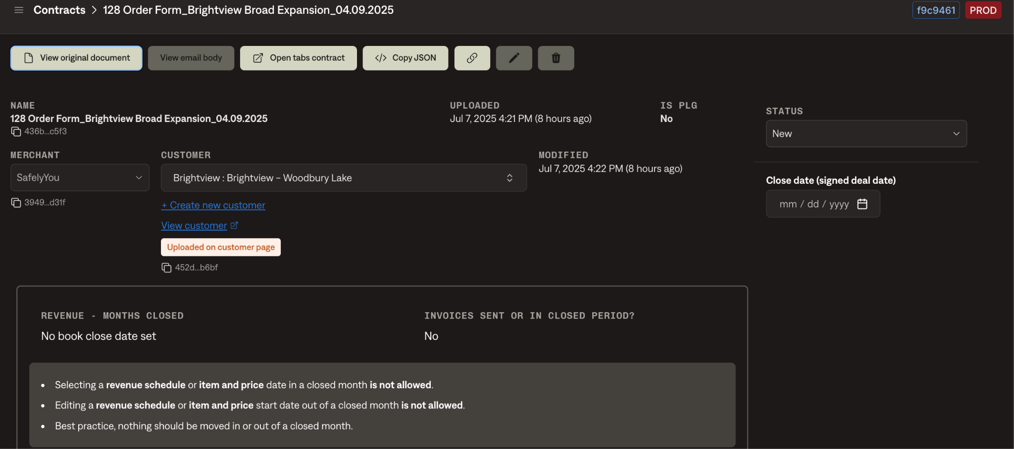





**Flat Fee or Usage BT**

* If the maximum number of beds is being used, create a flat fee product
* Else, create a usage product
* Below is a markdown of the columns and row for the same contract/example site above
  + Because min active MC beds is 21 (less than total beds of 26), we would create a usage BT

| Services/Site Name | Total Beds | Min Active MC Beds | Price per Bed | Min Monthly |

|-----------------------------------|------------|--------------------|---------------|-------------|

| SafelyYou-Respond + Insights | | | | |

| Brightview Woodbury Lake | 26 | 21 of 26 | $110 | $2,310 |

**UNIVERSAL RULES FOR BILLING TIMING**

* For flat fee, use “first of period”
* For usage, use “bill last of period”
* **Except** if there are both flat and usage products on a contract, both products should have billing timing = “bill last of period”

Other exceptions

* If you see a contract that has an effective date **BEFORE** 2025, leave as “new” and flag in pylon ticket

**Service Start Date**:

* Use 8 months after the “Effective Date”

Historical Contracts:

~~Use the dates in this~~ [~~spreadsheet~~](https://docs.google.com/spreadsheets/d/17fKqevcLQSWyTyVZZ1E-VU-vkXbq7bIsSXxNUcDg9EQ/edit?gid=1687603556#gid=1687603556) ~~(the Rate & Go Live tab as the start date for their billing schedule + revenue schedules)~~

~~Logic for dates:~~

* ~~If they're not live yet, use the 8-month after signature date placeholder (“Effective Date”) we've used in the past~~
* ~~If they are live:~~
  + ~~Use the date in column D UNLESS the contract effective date is earlier than 2024, in which case use column C~~
  + **~~ADDITIONALLY i~~**~~f you are using column C and the Year in C~~ **~~DOES NOT~~****~~EQUAL~~** ~~the Year in D - please check if there is an automatic renewal clause~~
    - ~~If there is, please create additional BT for the~~ ~~renewal years~~
    - ~~Renewal BT service start date and billing start date should start the day after the last initial billing period~~
    - ~~Last BT year sequentially should be the same as column D in this case~~

## **MONTH 1 BT - create for EVERY community (regardless of service start date):**

* Create a BT for month 1 (I’m going to call this **REV SCHED 1 / 2**) - the item name, billing start date, periods, and frequency will be the **only different** values compared to the BT for the rest of the billing period (**REV SCHED 2 / 2)**
* In the example below (Beacon at Gulf Breeze), the spreadsheet says that the service start date (column C) is 12/19/2024

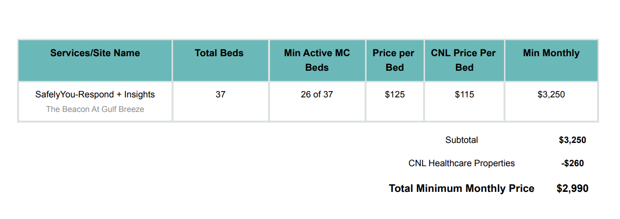

* + **REV SCHED 1 / 2** would have the following categories:
  + **Billing Type:** Usage
  + **Service Start Date:** 12/19/2024
  + **Months of Service:** 24
  + **Item Name:** follow [instructions](https://docs.google.com/document/d/1g621w03TNiUp6Q1xsR1uP-pIe6Gl2IHR0o5HkD5fH4w/edit?pli=1&tab=t.0#heading=h.9xvffhsw9a4a) below but add “ - Month 1”
    - “SafelyYou Respond MC - Month 1”
  + **Billing Start Date:** 12/1/2024
  + **Unit Price:** $115
    - **You do not have to prorate!!**
  + **Periods:** 1
  + **Frequency:** 1 **month**
  + **Billing Timing:** bill *last of period*
  + *\*\**
* If this contract had min active beds = to total beds (37),  **REV SCHED 1 / 2** would have the following categories:
  + **Billing Type:** Flat
  + **Service Start Date:** 12/19/2024 (same as usage)
  + **Months of Service:** 24 (same as usage)
  + **Item Name:** follow [instructions below](https://docs.google.com/document/d/1g621w03TNiUp6Q1xsR1uP-pIe6Gl2IHR0o5HkD5fH4w/edit?pli=1&tab=t.0#heading=h.9xvffhsw9a4a) but add “ - Month 1”
    - “SafelyYou Respond MC - Month 1”
  + **Billing Start Date:** 12/1/2024 (same as usage)
  + **Total Price:** min monthly (which would = 37*115)
    - **You do not have to prorate!!**
  + **Periods:** 1 (same as usage)
  + **Frequency:** 1 **month** (same as usage)
  + **Billing Timing:** bill *first* of period
  + *\*\**

*\*\* for the other BT categories, please reference below*

* ~~You will need to create a Prorated First Month BT (I’m going to call this~~ **~~REV SCHED 1 / 2~~**~~) - the item name, billing start date, periods, and frequency will be the~~ **~~only~~** ~~different values compared to the BT for the rest of the billing period (~~**~~REV SCHED 2 / 2)~~**
* ~~In the example below (Beacon at Gulf Breeze), the spreadsheet says that the service start date (column C) is 12/19/2024~~
  + **~~REV SCHED 1 / 2~~** ~~would have the following categories:~~
  + **~~Billing Type:~~** ~~Usage~~
  + **~~Service Start Date:~~** ~~12/19/2024~~
  + **~~Months of Service:~~** ~~24~~
  + **~~Item Name:~~** ~~follow~~ ~~instructions~~ ~~below but add “ - Month 1”~~
    - ~~“SafelyYou Respond MC - Month 1”~~
  + **~~Billing Start Date:~~** ~~12/19/2024~~
  + **~~Unit Price:~~** ~~$115~~
  + **~~Periods:~~** ~~1~~
  + **~~Frequency:~~** ~~12~~ **~~days~~** ~~(in any case, use however many days gets you to the end of the month)~~
  + **~~Billing Timing:~~** ~~bill~~ *~~last of period~~*
  + *~~**~~*
* ~~If this contract had min active beds = to total beds (37),~~  **~~REV SCHED 1 / 2~~** ~~would have the following categories:~~ 
  + **~~Billing Type:~~** ~~Flat~~
  + **~~Service Start Date:~~** ~~12/19/2024 (same as usage)~~
  + **~~Months of Service:~~** ~~24 (same as usage)~~
  + **~~Item Name:~~** ~~follow~~ ~~instructions below~~ ~~but add “ - Month 1”~~
    - ~~“SafelyYou Respond MC - Month 1”~~
  + **~~Billing Start Date:~~** ~~12/19/2024 (same as usage)~~
  + **~~Total Price:~~** ~~min monthly (which would = 37*115) / days in the month (31 for december) * days of service remaining in the month (12)~~
  + **~~Periods:~~** ~~1 (same as usage)~~
  + **~~Frequency:~~** ~~12~~ **~~days~~** ~~(in any case, use however many days gets you to the end of the month) (same as usage)~~
  + **~~Billing Timing:~~** ~~bill~~ *~~first~~* ~~of period~~
  + *~~**~~*

## **THEN CREATE REV SCHED 2/2 FOR THE REMAINDER OF THE TERM:**

For **REV SCHED 2/2** (the second BT for the remaining billing period / the counterpart to Rev Sched 1 /2), follow the steps below.

* Rev Sched 2/2 should have the same service start date and months of service as Rev Sched 1/2

**Months of Service**: Use the number of months as specified under "Subscription Term"

**Item Name**: Use the service label from the first column, e.g., "SafelyYou-Respond + Insights MC". **BUT DON’T INCLUDE** “Insights”

* In this case, it would be “SafelyYou Respond MC”
* If the column said “Min Active **AL** Beds” use “SafelyYou Respond AL”
* If the column has nothing stated, it would just be SafelyYou Respond

The item name should match a product in column C of this [spreadsheet](https://docs.google.com/spreadsheets/d/1SRZDlanYyXsFI_d9dAF2B0nt_5_DecZLVhSlA2zDTnI/edit?gid=0#gid=0)

**Item Description**: Use description in column E for the correct product/row of this [spreadsheet](https://docs.google.com/spreadsheets/d/1SRZDlanYyXsFI_d9dAF2B0nt_5_DecZLVhSlA2zDTnI/edit?gid=0#gid=0)

**Integration Item**: Use column D in [spreadsheet](https://docs.google.com/spreadsheets/d/1SRZDlanYyXsFI_d9dAF2B0nt_5_DecZLVhSlA2zDTnI/edit?gid=0#gid=0) for the right row/product

**Quantity**:

* If flat fee, use the "total beds" value for each row
* If usage, n/a

**Total Price**:

* If flat fee, use the "Min Monthly" column. These are monthly fees, based on active beds multiplied by $[ ] each
* If usage, use “price per bed”
  + If there is a discounted column like “[CNL] Price Per Bed”, use that value
  + Event to track should be “[name following “Min Active” in Min Active Column] beds”
    - There should **be no duplicate** events to track, if you are creating two BT with the same billing period/frequency AND the same event to track please flag in pylon
    - **PLEASE!!!! Pay attention to the above ^^**

**Billing Start Date:**

* For **REV SCHED 2/2**, use the first of the following month
  + Example above would be 1/1/2025

**# of Periods**

* For **REV SCHED 2/2**, use the number of months as specified under "Subscription Term" ***minus***1

**Frequency**: Set to Monthly, unless stated otherwise

**Net Terms**: If not explicitly listed in the PDF; default to Net 30

**Billing Timing:**

* For flat fee, use “first of period”
* For usage, use “bill last of period”
* **Except** if there are both flat and usage products on a contract, both products should have billing timing = “bill last of period”

**NO LONGER CREATING USAGEAI**

**~~USAGE AI:~~**

* ~~Not necessary to create for flat fee BT~~
* ~~For USAGE BT - please create!!!~~
  + ~~Set to “Has Minimum”~~
  + ~~Usage Name: Same as Item Name~~
  + ~~Included products: select ONLY the product associated with~~ **~~REV SCHED 2/2~~** ~~(product name~~~~does~~ **~~not~~** ~~have~~~~“- Month 1”~~**~~)~~**
  + ~~Minimum period: “Individual billing period”~~
  + ~~Minimum amount: “Min Monthly” column amount~~
  + ~~Integration Item: same as the one selected for~~ **~~REV SCHED 2/2 and REV SCHED 1/2~~**
  + ~~Select “True up to meet minimum”~~

### Renewal BT:

* If there are “autorenewal terms”, please duplicate Rev Sched 2/2 and adjust for the following year and make sure # of periods = 12
* ~~If you are creating renewal BT, the service start date and billing start date should start the day after the last billing period~~
* ~~You should not need to split renewal BT into two product/billing periods (like rev sched 1 / 2 or 2/2) because it should always start on the first of a month~~
* ~~Last BT year sequentially should be the same as~~ [~~column D~~](https://docs.google.com/spreadsheets/d/17fKqevcLQSWyTyVZZ1E-VU-vkXbq7bIsSXxNUcDg9EQ/edit?gid=1687603556#gid=1687603556) ~~in this case~~

**Implementation Fees**: **DO NOT** process anything in the implementation section

**Other format of contracts:**

118eae00-c274-4bf1-843a-ad3c5e6232ac (this one is done correctly so can use as an example)

* Some contracts look like the below. For these, please do the following:
  + Create flat fee BT for the minimum number of beds (still following proration logic if needed based on the service start date)
  + Create a usage BT for “Monthly Fee per bed”
    - If you are creating a prorated first month BT, this usage BT should follow the same rules as Rev Sched 2/2
    - If you are not creating a prorated first month BT, create this usage BT following the general rules
      * This BT should be the same as the flat fee except for billing type, total price, and billing timing
    - You do **not** need to create usage AI for these contracts
    - You should just be duplicating the flat fee (rev sched 2/2 product, if applicable) and changing it to unit price, changing the total price, and billing timing to last of period

If you see other different contract formats and are confused, please create a processing reminders ticket and tag me



**Example contracts:**

1. **Ignore**:
   1. Any fees in the implementation section
      1. This means no need to create unit BT for additional cameras
   2. Any other BT that are discounted 100%
   3. SafelyYou-Clarity BETA program terms (non-billable trial program)
   4. Any references to excess camera installs
2. Specifics processing things the merchant has requested that may differ by contract (e.g. always back-date invoice date to final day of the month)
3. Default Service Term
   1. If None Listed, Ops Default is 1 Year
4. Default Net Payment Terms
   1. If None, Ops Default is 30
5. Default Billing Frequency
   1. If None Listed, Ops Default is Monthly
6. How do we handle taxes as a line item?
   1. If None Listed, Ops Default is every tax line item becomes a BT

### Events Processing (if necessary) *(Entire Section: Implementation/Success to fill Post-Go Live)*

* Any important information on events billing

Integration Items Processing (if necessary)  
*(Entire Section: Implementation/Success to fill Post-Go Live)*

* What are the instructions for assigning integration items?
* Example: All Statsig integrations items should be labeled as “Sales”
* Example: All “Pinata” integration items should be labeled as “Software Subscription Bundle” unless otherwise noted by Merchant

Post Processing Communications (if necessary)  
*(Entire Section: Implementation/Success to fill Post-Go Live)*

* Does the Ops Team need to notify anyone on the team re: completion of processing batches in Implementation or Active phase?
* Who needs to be notified and when?
  + Example:
    - Who: Customer Success [Azmat Aziz] needs to be notified
    - Where: Messari internal merchant channel
    - When: contracts are processed [Merchant Phase: Active]

### Customer Information *(Entire Section: Implementation/Success to fill Post-Go Live)*

* Any important information on specifics customers of this merchant
  + Special memo’s certain invoices require
  + Invoice changes due to merchant/customer relationship

### Feature Requests *(AE to fill for all requests prior to Imp handoff, Imp to fill prior to go-live/Success to fill to fill Post-Go Live)*

* FR 1
  + What is it
  + Why it's important
  + Urgency

### Merchant Calls *(AE to fill for all videos prior to Imp involvement, Imp to fill prior to go-live/Success to fill to fill Post-Go Live)*

* .
* .
* .